2026 Summer Reading List

Compiled by the Office of Practice and Community Engagement at LSUHealth New Orleans

School of Public Health for your reading and listening pleasure!

Top Reads
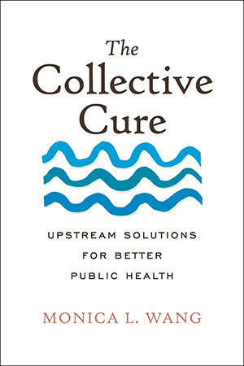  The Collective Cure: Upstream Solutions for Better Public Health  Monica L Wang |  | 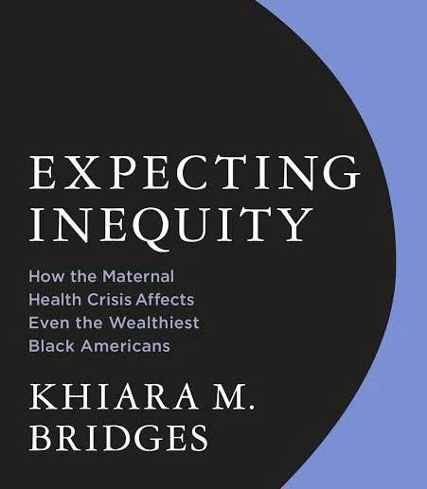  Expecting Inequity: How the Maternal Health Crisis Affects Even the Wealthiest Black Americans  Khiara Bridges |  |  | 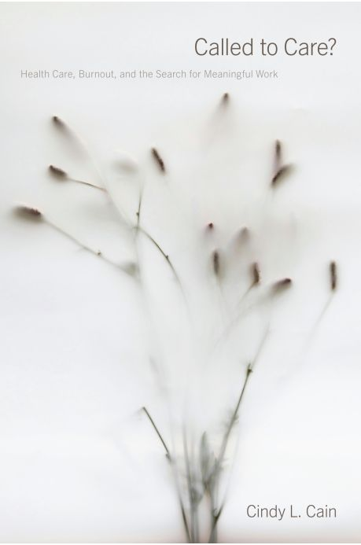  Called to Care? : Healthcare, Burnout, and the Search for Meaningful Work  Cindy L Cain
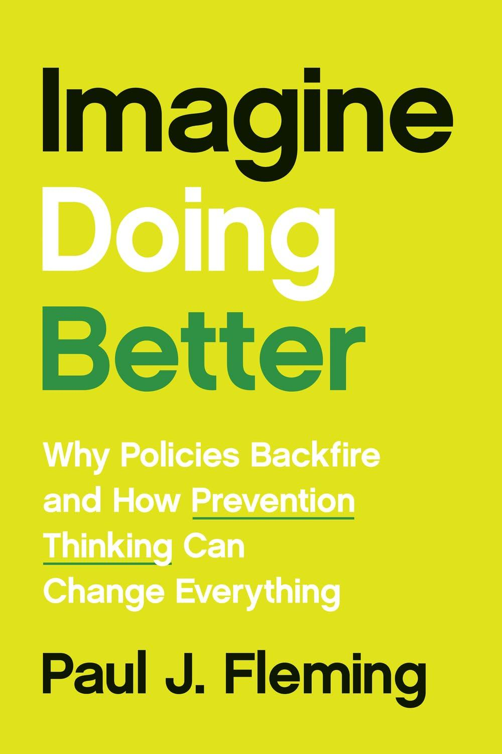  Imagine Doing Better: Why Policies Backfire and how Prevention Thinking Can Change Everything  Paul J. Fleming |  | 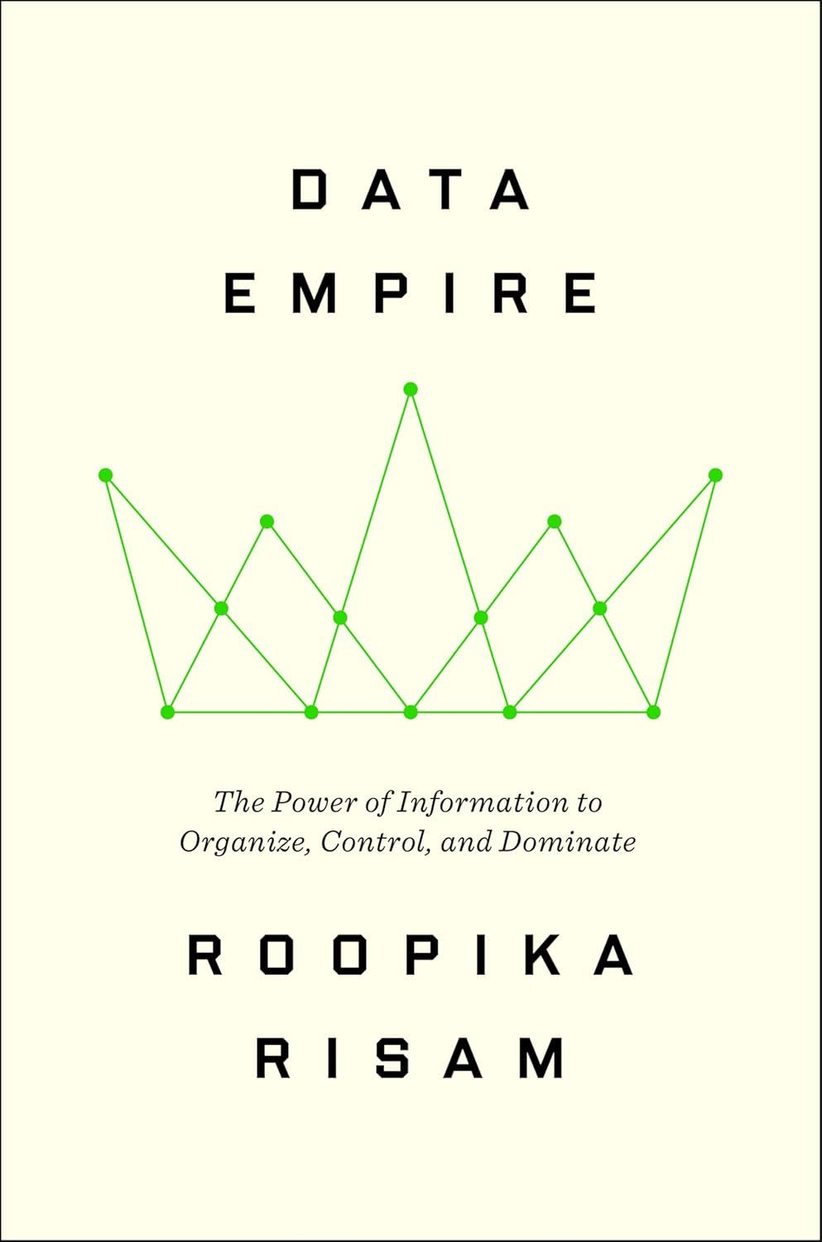  Data Empire: The Power of Information to Organize, Control, and Dominate  Roopika Risam |  |  | 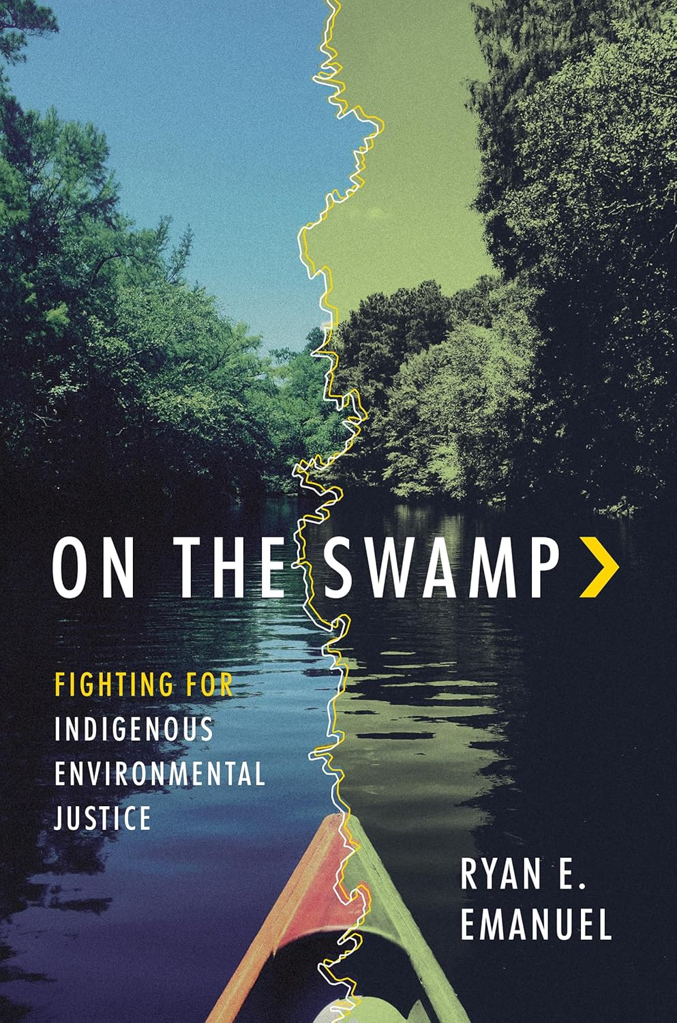  On The Swamp: Fighting For Indigenous Environmental Justice  Ryan E. Emanuel

Health and Medicine
Title: | Author: |  | Description: | Access: |  | Rating:
Everything Is Tuberculosis | John Green |  | Tuberculosis, a curable disease, remains the world's deadliest infection due to healthcare inequities. | Everything Is Tuberculosis by John Green |  | Great read
Anti-vaxxers | Jonathan M. Berman |  | Explores the history of the anti-vaccination movement, from its 19th-century antecedents to modern-day activism. | MIT Press: Anti - Vaxxers |  | Great read
Mapping Medical Anthropology for the 21st Century | Matthew J. Wolf-Meyer, Junko Kitanaka, and Eugene Raikhel |  | Comprehensive survey of the field's key concepts, methodologies, and theories. | Rutgers University Press: Mapping Medical Anthropology |  | Great read
The Power to Harm and Heal | Joshua Mentanko |  | Histories of Indigenous healing and Western medicine in Chiapas. | UNC Press : The Power to Harm and Heal |  | Great read
Accessing Abortion Global and Comparative Perspectives | Rachel Rebouchea and Mindy Jane Roseman |  | Explores the global landscape of abortion law reform. | NYU Press: Accessing Abortion |  | Great read
God Bless the Pill  The Surprising History of Contraception and Sexuality in American Religion | Samira K. Mehta |  | How American religious leaders and their congregations debated—and embraced—contraception in the postwar era. | The University of North Carolina Press |  | Great read
The Preventioneers: Diseases, Disasters, and the Discoveries that Changed our World | Barry R. Davis |  | Inspiring stories of individuals who shaped prevention as a public good. | Johns Hopkins University Press |  | Great read

America Turns 250
  American Patriarch: The Life of George Washington by HW Brands  HW Brands |  | 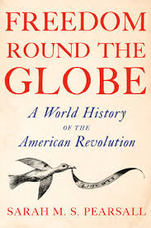  Freedom Round the Globe: A World History of the American Revolution  Sara M.S. Pearsall |  |  | 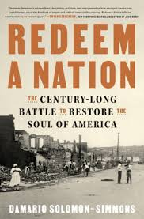  Redeem a Nation: The Century-Long Battle to Restore the Soul of America  Damario Solomon Simmons
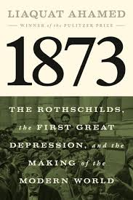  1873 : The Rothschilds, the First Great Depression, and the Making of the Modern World  Liaquat Ahmed |  | 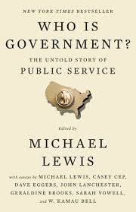  Who is Government?  The Untold Story of Public Service  Michael Lewis |  |  | 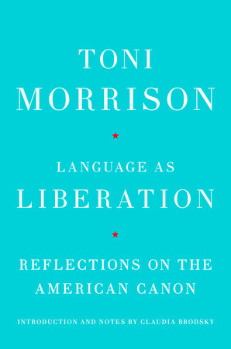  Language as Liberation: Reflections on the American Cannon  Toni Morrison

Social, Political & Environmental
Title: | Author: |  | Description: | Access: |  | Rating:
Backtalker | Kimberle Crenshaw |  | How personal trauma spurred influential and controversial ideas about race and intersectionality. | Backtalker | Book by Kimberlé Williams Crenshaw | Official Publisher Page | Simon & Schuster |  | Great read
Muñeca | Cynthia Gomez |  | A fantasy novella about identity, class, and heritage. | Penguin Random House: Muneca |  | Great read
Names Have Been Changed | Yu-Mei Balasingamchow |  | A story about displacement, immigration, and ultimately belonging. | Penguin Random House: Names Have Been Changed |  | Great read
Injustice Town | Ricky Tulsky |  | Injustice Town is both a gripping true-crime story and an exposé of systemic rot at the core of a Midwest city's government and police department. | Simon and Schuster Publishing: Injustice Town |  | Great read
The Death and Life of Gentrification | Japonica Brown-Saracino |  | A provocative account of what is gained and what is lost when a word that once narrowly referred to neighborhood change takes on a life all its own. | Princeton Press: The Death and Life of Gentrification |  | Great read
Biological War | Annie Jacobsen |  | Jacobsen examines a biological warfare scenario through expert interviews, exploring how a lab accident or bio-attack could trigger a global pandemic. | Penguin Random House: Biological War |  | Great read
Catch The Devil | Pamela Colloff |  | A storied criminal justice reporter's first book tracks how a serial liar conned the courts — and sent dozens of people to prison. | Catch the Devil by Pamela Colloff: | PenguinRandomHouse.com: Books |  | Great read
Peak Higher ED | Bryan Alexander |  | Mapping out the strategic future of higher education. | Peak Higher Ed | Hopkins Press |  | Great read
Attack From Within | Barbara McQuade |  | Legal scholar and analyst Barbara McQuade, shows us how to identify the ways disinformation is seeping into all facets of our society. | Attack from Within by Barbara McQuade: | PenguinRandomHouse |  | Great read

Lagniappe
TED Talk  Podcast  In conversation with TED’s Helen Walters, Political scientist Ian Bremmer opens up about how he thinks about sources, how he avoids getting spun — and what we can all do to think more clearly about the news.  How to be smarter about the news | Ian Bremmer |  | PBS  Documentary  The Invisible Shield, a four-part documentary series, reveals a little-known truth: that public health saved your life today and you probably don’t even know it. But while public health makes modern life possible, the work itself is often underfunded, undervalued, and misunderstood.  The Invisible Shield | PBS |  |  | Democracy Now!  YouTube video  Leading scholar in the field of critical race theory Kimberlé Crenshaw coined the term "intersectionality," which she has described as a "lens through which you can see where power comes and collides, where it interlocks and intersects." "Backtalker": Kimberlé Crenshaw on New Memoir, Voting Rights, Critical Race Theory & Clarence Thomas
Spotify  Playlist  Democracy Forward: Official Playlist |  | Today Show  YouTube video  Jenna Bush Hager Sits Down With Former Presidents George Bush, Bill Clinton, Barack Obama and Joe Biden - The four living former presidents each shared a message for the American people ahead of the nation's 250th anniversary in July. EXCLUSIVE: Clinton, Bush, Obama and Biden Share Message for America250 |  |  | Apple Music  Playlist  Jazz at The Lincoln Center  JAZZ AND DEMOCRACY  Playlist on Apple
Sources:
- 15 books our critics can't wait for this summer
- TIE Preview of Upcoming Reads on Health and Medicine, 2026 - Choice 360
- New Nonfiction To Read This Summer | Penguin Random House
- TIE Preview of Upcoming Reads on Health and Medicine, 2026 - Choice 360
- Penguin Random House Top Reads
- MIT Press
- NYU Press
- Johns Hopkins University Press
- Simon & Schuster
- Princeton University Press
- The University of North Carolina Press
- PBS.org
- Rutgers University Press

