Title
Implicit bias and racial disparities in school discipline responses in Louisiana
Corresponding Author
Casey L. Thomas
ctho44@lsuhsc.edu
Phone: (985) 290-0986
Fax: (504) 568-5701
Co-Authors
Casey L. Thomas¹, Kaylin Beiter¹, Ashley Fenton¹, Stephen Phillippi¹
Affiliations
- Louisiana State University Health Sciences Center in New Orleans, School of Public Health, Department of Behavioral and Community Health Sciences, New Orleans, LA

Abstract
Background: In Louisiana schools, there is high incidence and racially disparate use of suspension and expulsion. This analysis assessed parish-level associations between racial disparities in school discipline and implicit racial biases.
Methods: Investigators examined disparities in the proportion of Black students experiencing a school discipline outcome relative to White peers from all parishes (N=64) over four years. Implicit bias measures were derived from scores on the Implicit Association Test (IAT), which estimates a participant’s implicit associations between race categories and positive or negative feelings. IAT test date was used to stratify results by school year. The analysis included 10,652 IAT scores. Multilevel regression modeling examined parish-level differences in school discipline outcomes as associated with IAT data.
Results: Results show that implicit biases are significantly associated with racial disparities in the use of in-school suspension.
Conclusion: Unconscious bias may affect school discipline decisions, suggesting the need for multi-tiered intervention.
Keywords: schools; education; school discipline; racial disparities

Introduction
In Louisiana, the rates of school suspension and expulsion are among the highest in the nation, and evidence demonstrates significant racial disparities in the use of these disciplinary procedures.¹ In 2016, the Louisiana Department of Education reported that Black children accounted for approximately 65% of suspensions and 68% of expulsions statewide, despite representing 44% of public school enrollment.¹ Now considered public health crises, research shows meaningful links between school discipline and absenteeism, grade repetition, school failure, dropout, and contact with the justice system.²
Increasingly, research implicates the role of unconscious bias in the disproportionate discipline of Black students.³ In the United States, Black children are more than three times as likely to be suspended or expelled as White students.⁴ However, there is no evidence to suggest this overrepresentation is due to disproportionate rates of misbehavior among Black children. In fact, previous research indicates that Black students are often subject to higher rates of severe punishment for less serious, more subjective infractions than their White peers.^{3,4}
Education is a well-documented social determinant of health, predictive of life expectancy, morbidity, health behavior, and economic stability.⁵ There is a need to examine the explanatory factors underlying disparities in suspension and expulsion, which are known barriers to educational attainment. Given the high incidence and racially disparate application of suspension and expulsion in Louisiana public schools, the objective of this analysis was to assess parish (county) level associations between racial disparities in school discipline and implicit racial biases.

Methods
In the present study, investigators examined data for the 2015–16 through 2018–19 school years from all Louisiana parishes (N=64). To determine the association between racial disparities in school discipline outcomes and regional estimates of implicit bias, data were collected from the following sources: (1) the Louisiana Department of Education; and (2) Project Implicit, which hosts the largest known repository of data regarding bias.
School discipline rates were available at the parish level per racial group. Investigators examined disparities in the proportion of Black students experiencing a school discipline outcome relative to White peers. Specifically, differences in the proportion of disciplinary rates for Black vs. White students were used as the outcome variable for the following outcomes: In-School Suspension (ISS), Out-of-School Suspension (OSS), In-School Expulsion (ISE), and Out-of-School Expulsion (OSE).
Implicit bias measures were derived from respondent scores on the Implicit Association Test (IAT), which estimates a participant’s implicit associations between race categories and positive or negative feelings. Positive IAT scores demonstrate an association between white race and positive feelings (pro-White), and Black race with negative feelings (anti-Black). Negative IAT scores reflect the opposite. A score of zero indicates no implicit association. IAT test date was used to stratify results by school year, with August 1, 201X–July 31, 201X+1 constituting an entire school year. The analysis included a total of 10,652 IAT scores.
Multilevel regression modeling examined parish-level differences in school discipline outcomes as associated with IAT data. Statistical analyses were conducted using SAS Version 9.4. Data were geocoded and visualized using ArcGIS Desktop 10.7.1 (Esri).

Results
Analyses showed that IAT scores ranged from -1.588 to 1.712. The majority of scores were positive, indicating a greater proportion of pro-White/anti-Black implicit bias (7,567 scores ≥ 0.01; 2,938 scores ≤ -0.01; and 147 scores between -0.01 and 0.01). Multilevel models demonstrated a significant positive association of IAT scores with the disparity in proportion of ISS rates for Black students relative to White students (p<0.0001), after adjusting for academic year and respondent age, race, and gender. There was no association between IAT score and racial differences in OSS rates (p=0.063). See Table 1 and Figure 1. Due to a limited amount of data, models did not converge when tested for expulsion.
Discussion
The results of this study indicate that implicit biases at the parish-level are significantly associated with racial disparities in the use of in-school suspension, but not out-of-school suspension in Louisiana public schools. These findings suggest a permeation of racism into the state’s public school system when assessing and administering consequences for minor, subjective misbehaviors that do not meet criteria for out-of-school suspension. Consistently, research shows a meaningful link between school discipline and poor life outcomes that include school dropout, justice system contact, economic instability, and worse health status.⁵⁻⁷ In addition to short-term, culturally-relevant implicit bias training to address racism as a barrier to Black student success, schools will need longer-term solutions, such as multi-tiered behavioral interventions and restorative justice.⁸ As systemic approaches, these initiatives will reduce structural racism in Louisiana public schools and build a more equitable society in which Black students can learn and thrive.
References
- US Department of Education Office for Civil Rights. 2015-2016 civil rights data collection: School climate and safety. https://www2.ed.gov/about/offices/list/ocr/docs/school-climateand-safety.pdf. Accessed November 1, 2020.
- Welsh RO, Little S. Caste and control in schools: A systematic review of the pathways, rates and correlates of exclusion due to school discipline. Children and Youth Services Review. 2018;94:315-339.
- Gregory A, Skiba RJ, Mediratta K. Eliminating disparities in school discipline: A framework for intervention. Review of Research in Education. 2017;47:253-278.
- Welsh RO, Little S. The school discipline dilemma: A comprehensive review of disparities and alternative approaches. Review of Educational Research. 2018;88:752-794.
- The Lancet Public Health. Education: A neglected social determinant of health. The Lancet Public Health. 2020;5:e361.
- Barnes JC, Motz RT. Reducing racial inequalities in adulthood arrest by reducing inequalities in school discipline: Evidence from the school-to-prison pipeline. Developmental Psychology. 2018;54:2328-2340.
- Curran CF. Estimating the effect of state zero tolerance laws on exclusionary discipline, racial discipline gaps, and student behavior. Educational Evaluation and Policy Analysis. 2016;38:647-668.
- Darling-Hammond S, Fronius TA, Sutherland H, Guckenburg S, Petrosino A, Hurley N. Effectiveness of restorative justice in US K-12 schools: A review of quantitative research. Contemporary School Psychology. 2020;24:295-308.
Table 1. Multilevel regression modeling of IAT scores with disciplinary outcomes

Model 1: Examination of In School Suspension
 | β | P
Intercept | 0.085 | 0.004
Gender | 0.0004 | 0.786
Race |  | <.0001
Asian | -0.015
Black | -0.006
Other | -0.010
Age | -0.0002 | <.0001
IAT Score | 0.009 | <.0001
Model 2: Examination of Out of School Suspension
 | β | P
Intercept | 0.069 | 0.001
Gender | 0.001 | 0.278
Race |  | 0.654
Asian | -0.002
Black | -0.002
Other | -0.0003
Age | 0.00005 | 0.234
IAT Score | 0.002 | 0.063
Note: The full model in each case was the parish-level difference in suspension rates between Black and White students (outcome) as pertaining to IAT score (predictor of interest), with adjustment for student gender, race, and age. Parish data were nested within disciplinary year. Reference groups included male (gender) and White (race).

Figure 1. In-school suspension differences and average implicit association test scores by parish in Louisiana (2018–2019)
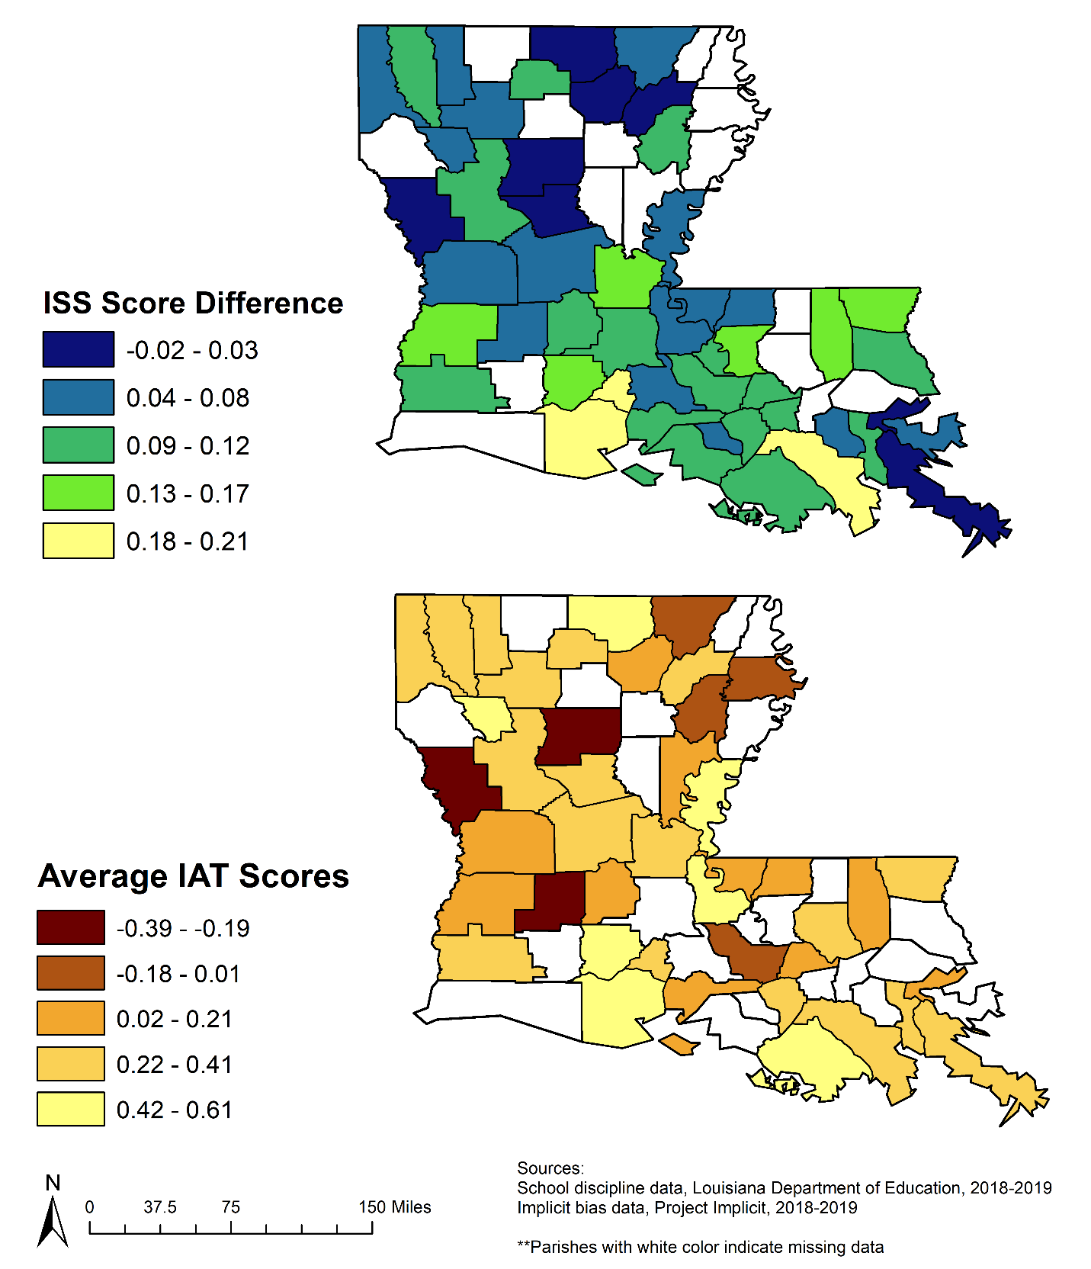
Figure Caption
Note: ISS: In-School Suspension, IAT: Implicit Association Test score.
Top map shows the difference in proportion of ISS rates experienced by Black vs. White students. Lighter colors reflect a larger difference between the proportion of Black vs. White students experiencing ISS.
Bottom map shows the average IAT scores of all respondents, at the county level. Lighter colors reflect a stronger implicit association between White race with positivity feelings and Black race with negative feelings.

